New corporate video
with a remarkable “star”

Klingenberg, January 2015.
For their new corporate video, WIKA has made an unusual choice for its main character − a small boy discovering the WIKA world.

“We are WIKA” is the central message of the film: committed employees as the foundation of a customer-orientated and quality-conscious strategy. The WIKA group of companies is now a leading global player in the field of measurement technology for pressure, temperature, level and flow, and also for calibration solutions. Despite their success, WIKA remains a family business, which is also a core message of the film.

The corporate video is available in German and English. You can view it on www.youtube.com/wikagroup.

Number of characters: 716
Key words: WIKA corporate film

Manufacturer:
WIKA Alexander Wiegand SE & Co. KG
Alexander-Wiegand-Straße
63911 Klingenberg
Tel +49 9372 · 132-0
Fax +49 9372 · 132-406
E-mail Vertrieb@wika.com
Internet www.wika.com

WIKA company photographs:
WIKA corporate film

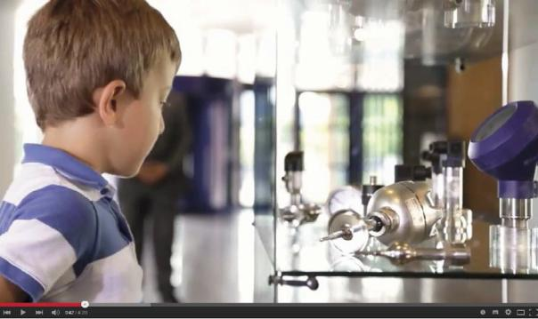

Edited by:
WIKA Alexander Wiegand SE & Co. KG
André Habel Nunes
Marketing Services
Alexander-Wiegand-Straße 30
63911 Klingenberg/Germany
Tel. (+49) 9372 132-8010
Fax (+49) 9372 132-8008010
E-mail a.habel-nunes@wika.com
www.wika.com

WIKA press release 03/2015

